“Rushmoor Christmas Angels” December 2022 Newsletter.
Hello everyone,
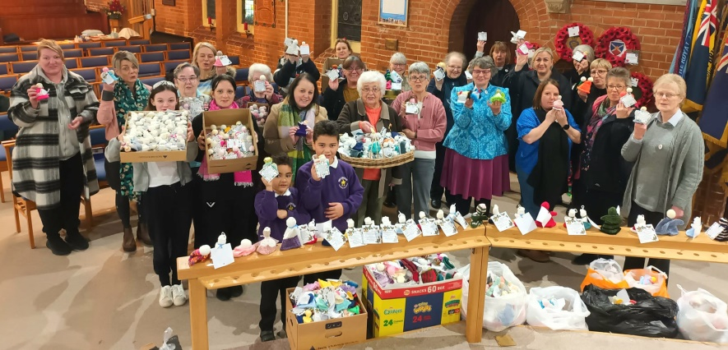
It’s December!!!…….and “Rushmoor Christmas Angels” 2022 launches in a just a few days. Who is else is excited….other than Elaine?

Those of you who are on the “Rushmoor Christmas Angels” Facebook page will have seen the 10 day countdown over the last week or so. It looks as though everyone is very much looking forward to our angels flying
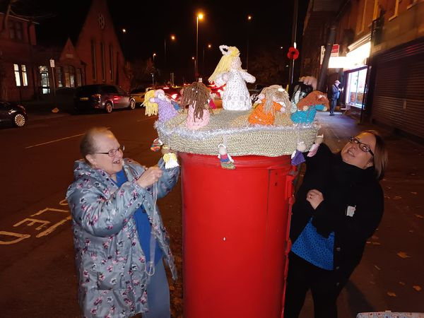
It was lovely to see you all at the recent “Dedication Service” alongside all the Angels that have been produced over the year. It is always great seeing all our Angels together in one place.

This Christmas we were able to place our first “Post Box Topper” on the post box outside the Post Office on Alexandra Road in North Camp. As well as this we placed Angels on the Traffic Bollards leading up to St Albans Roundabout. The next time you are travelling along Alexandra Road take a look. Even as these Angels were being put in place people were passing in their cars winding down their windows and shouting out how much they love our Angel project. Well done Jacqui for all you hard work in bringing this new idea to fruition.
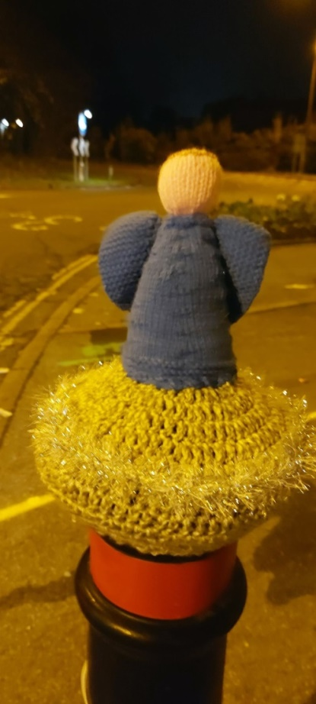
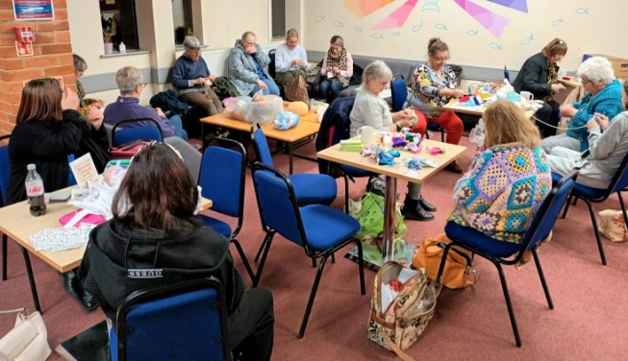
A big well done also to all who were at the last “Knitting party” and made sure that all the angels we have so far were all labelled and ready to go. When our project first began way back in 2015 we had “Angel week”. However over time we have realised a week isn’t long enough to distribute all the angels that are knitted….and anyway spreading out the distribution over 2 or 3 weeks makes the fun last that much longer. Feel free therefore to spread out distributing your angels all the way up to Christmas.

Don’t forget we are featured in the current edition of Prima magazine, so do see if you can get a copy.
Let’s look forward to seeing all the photos as our Angels are “found” and given homes for Christmas.

If you are the point of contact for a knitting group or church could you please pass this newsletter onto members of your team and if possible display this on your church noticeboard.

David Betts, 7 Redvers Buller Road, Aldershot, GU11 2LT. dabetts4x4@btinternet.com 01252 328959 or 07941 997841

