“Rushmoor Christmas Angels” May newsletter.

Hello everyone,
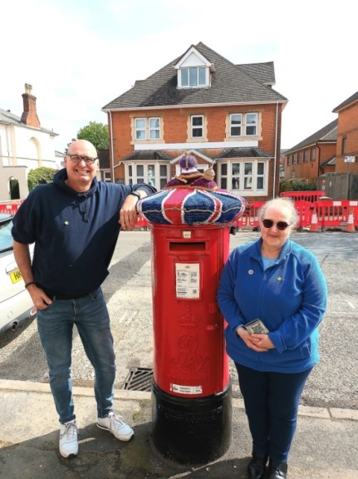
Well, here we are in May, almost half way through another year. It won’t be too long until things are ramping up ready for Christmas 2023. But until then we have the King’s Coronation to look forward to. I am not sure that we always grasp the enormity of such events in our country’s history until the moment passes so it is really good that we got “ahead of the game” so to speak and put plans in place well ahead of time for RCA to be part of this historical occasion.
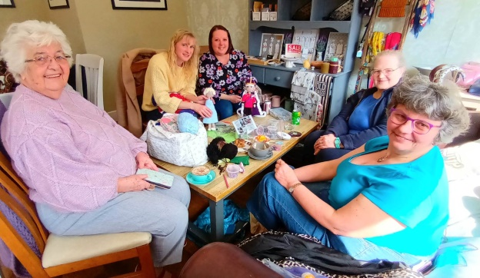
Firstly, a very big thank you to everyone who contributed to our knitted Coronation celebrations.

There have been a number of people seen taking pictures of “our” post box topper and loads of comments being made on various social media platforms. The postmaster was thrilled that we chose to “top” his post-box.

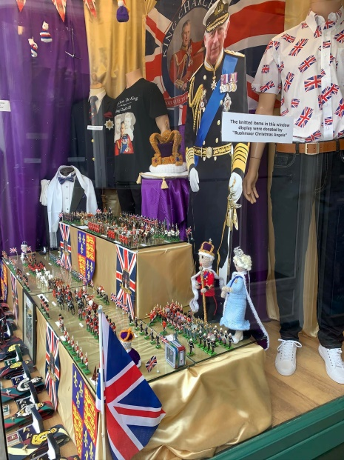
After the incident with our Christmas Post Box topper in December we took the precaution of chaining our Coronation post box topper with a padlock to the post box itself so hopefully it will remain there a lot longer than our Christmas topper did. We have learnt that there are cameras at the post office which are focussed on the post box so if this topper is taken (hopefully it won’t be) the postmaster will check his CCTV footage and we can find out what happened and when. Well done Jackie for all your hard work. The picture we shared on our Facebook page has in turn been shared a number of times.

John Jerome was thrilled with the items we offered to him to enhance his already amazing shop window display and I am sure over the next few weeks there will be many photos of the window display posted on social media. However, if you are in Aldershot do take a moment to go and see the window display for yourself, photos never really do the window.

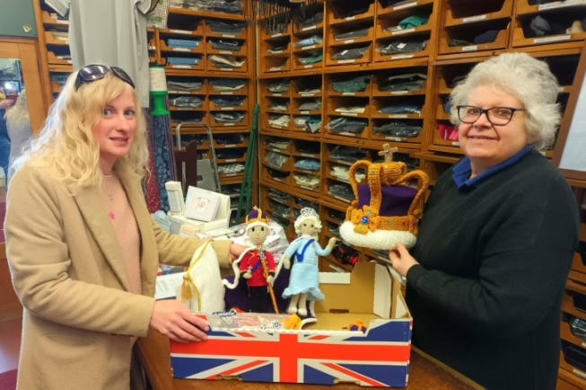
I have just realised this is the first time I have been featured in one of the pictures in one of our newsletters

Our next Knitting Party will be on 27th May at North Camp Methodist Church.

As always a massive thank you to ALL of you for all that you do to make this project what it is. I look forward to seeing you all soon.

David Betts, 7 Redvers, Buller Road, Aldershot, GU11 2LT. dabetts4x4@btinternet.com 01252 328959 or 07941 997841

