“Rushmoor Christmas Angels” February 2023 Newsletter.
Hello everyone,
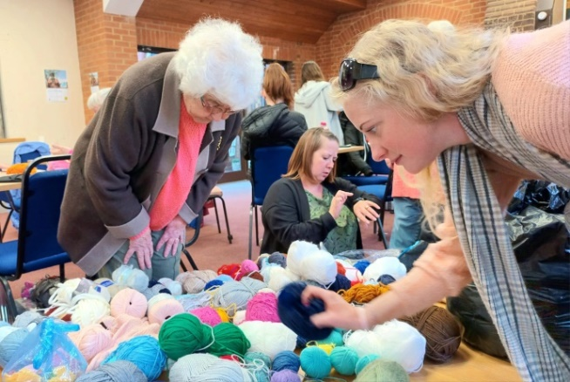
Where has January gone?…..it only seems a few days ago that we were taking down our Christmas decorations

There are now only 11 months to go until “Rushmoor Christmas Angels” 2023 launches. I know it sounds a long way off but as we are all very much aware the months fly by and each year our project seems to come around quicker than ever.

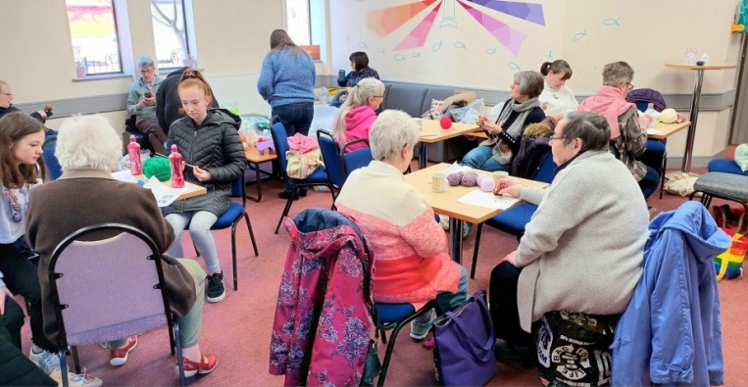
We never quite know what lays ahead for RCA each year…Who would have thought that this time last year we would feature in a national magazine? We have had a number of people contact us of the back of the article in “Prima” either offering to knit for “Rushmoor Christmas Angels” or asking for information so they can start a project local to where they are living. I have lost track now but over the 8 years RCA have been in existence there are at least 20 projects up and running off the back of RCA.

Last year saw us venture into the world of “Post Box Toppers”. Unfortunately someone was so keen to get hold of one of our knitted angels that they removed the whole “topper” from the post box where we had placed it. Never mind, next year we will fix it with small chain and padlock.
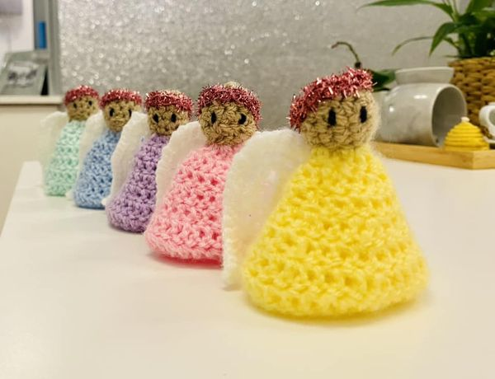
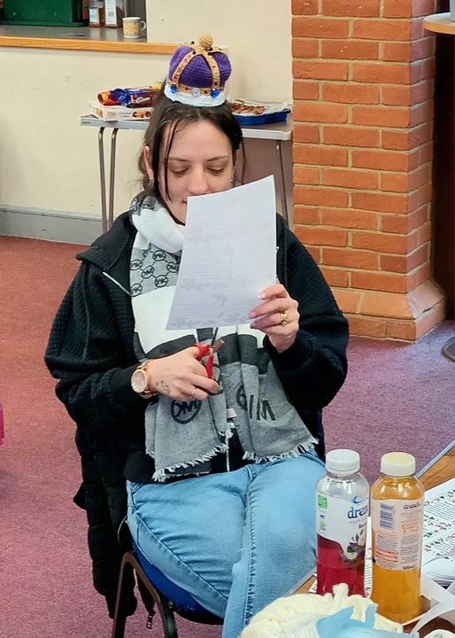
It was lovely to see everyone at our January knitting party; by all accounts we already have a fair few angels already knitted for Christmas 2023. Our next gathering will be on Saturday 25th Feb. We are always on the lookout for new knitters so if you know anyone who you think would enjoy knitting or crocheting Angels with us do encourage them to join the team.
With the king’s coronation in May fast approaching there are plans to celebrate this event in a typical “Woolly fashion”, quite possibly another “Post Box Topper”. More details to follow.

Fun Fact – Did you know that apparently someone who loves to knit or crochet is called a “Yarnie”

As always thank you so much for all that you do in making “Rushmoor Christmas Angels” such a fun and worthwhile project to be part of and it is wonderful seeing pictures of new angels appearing in our Facebook group each week.

David Betts,7 Redvers Buller Road, Aldershot, GU11 2LT. dabetts4x4@btinternet.com 01252 328959 or 07941 997841

