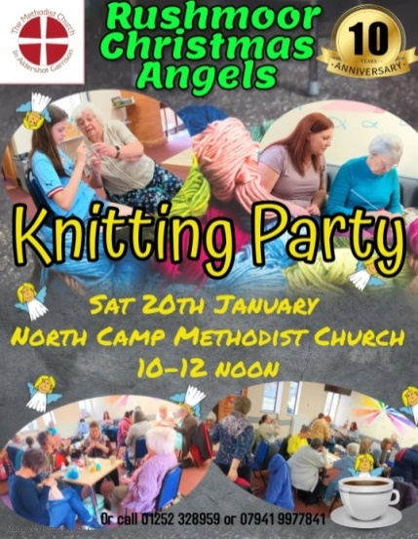
“Rushmoor Christmas Angels” Newsletter January 2024

Happy New year everyone! So here we are in our 10th anniversary year…….how exciting is that?

But before we think too far ahead let’s look back at RCA 2023. As usual our angels flew far and wide; Shipston on Stour in Warwickshire, Warrington Cheshire, Membury services (West Bound apparently) to name but a few places. One of our angels flew as far as Atlanta GA and another to New Zealand. Once again our project went global. As in previous years many of those who found one of our angels shared with us their “stories” as to why their angel was special to them. Below is just one of many posts I could have singled out.

“In January 2021 our daughter was born sleeping. Last year I felt incredibly depressed, another Christmas without her. I was walking and crying then I found one of these angels…..It stopped my tears and I smiled for the first time in a while. The angel is still in my hallway and I walk by her every day….thank you Rushmoor Christmas angels”.
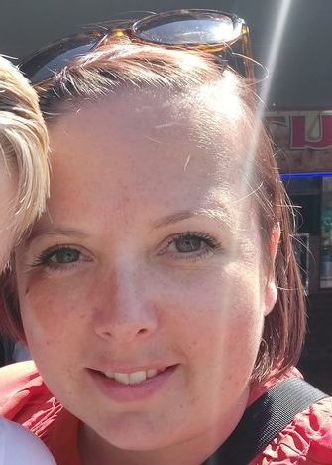
It is not just the “finders” of our angels that get a buzz. As we are all aware those who knit and place our angels are also blessed. This is Emma’s story and she has given me permission to share it with you.

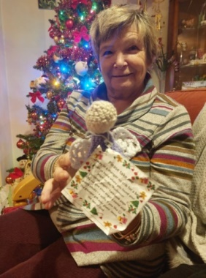
“Being part of this wonderful project over the past year has been amazing. We often talk about the stories people share and we have the belief that our angels “find” the people they are meant to. I had such and experience of this first hand. On Sunday the 10th December I was sitting in my car in Morrison’s car park. I felt drawn to the car that was parked in front of me feeling that whoever was driving that car needed something and I was the one who had it. I had a couple of angels in my bag so took one out and tucked it into the door handle. About 5mins later a lady came out, saw the angel and gave a look of “What has someone put on my car?” When she picked the angel up she had a huge smile on her face that quickly turned to tears. I sat watching her pretending I was on my phone. When I saw her cry I thought that I had “got it wrong” and wanted to reach out to her. But I decided to sit tight and hide under anonymity. The lady then put her shopping in the boot and go into her car. She sat for a moment crying but I could see she was looking at the angel. Then I saw her lift the angel to her lips and kiss it. With a look of both hope and gratitude she placed the angel next to her. I feel so blessed and humbled to have delivered and witnessed her receive a sign she obviously needed. I believe I did God’s work for him that day. A beautiful moment shared between us both without any of us knowing”

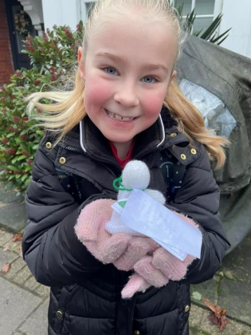
It is a privilege to work alongside you all and see the impact our project has in our community. Once again a massive thank you for all your continued hard work and let’s aim to make 2024, our 10th anniversary year the best yet.

Our first Knitting Party” of 2024 will be on Saturday 20th January…..and if you need any incentive to come along….I believe someone is bringing along some more wool for us

David Betts, 43 Redvers, Buller Road, Aldershot, GU11 2LY. dabetts4x4@btinternet.com 01252 328959 or 07941 997841

