****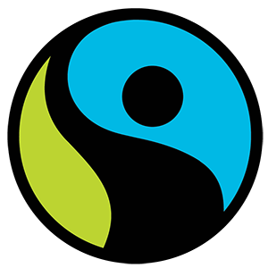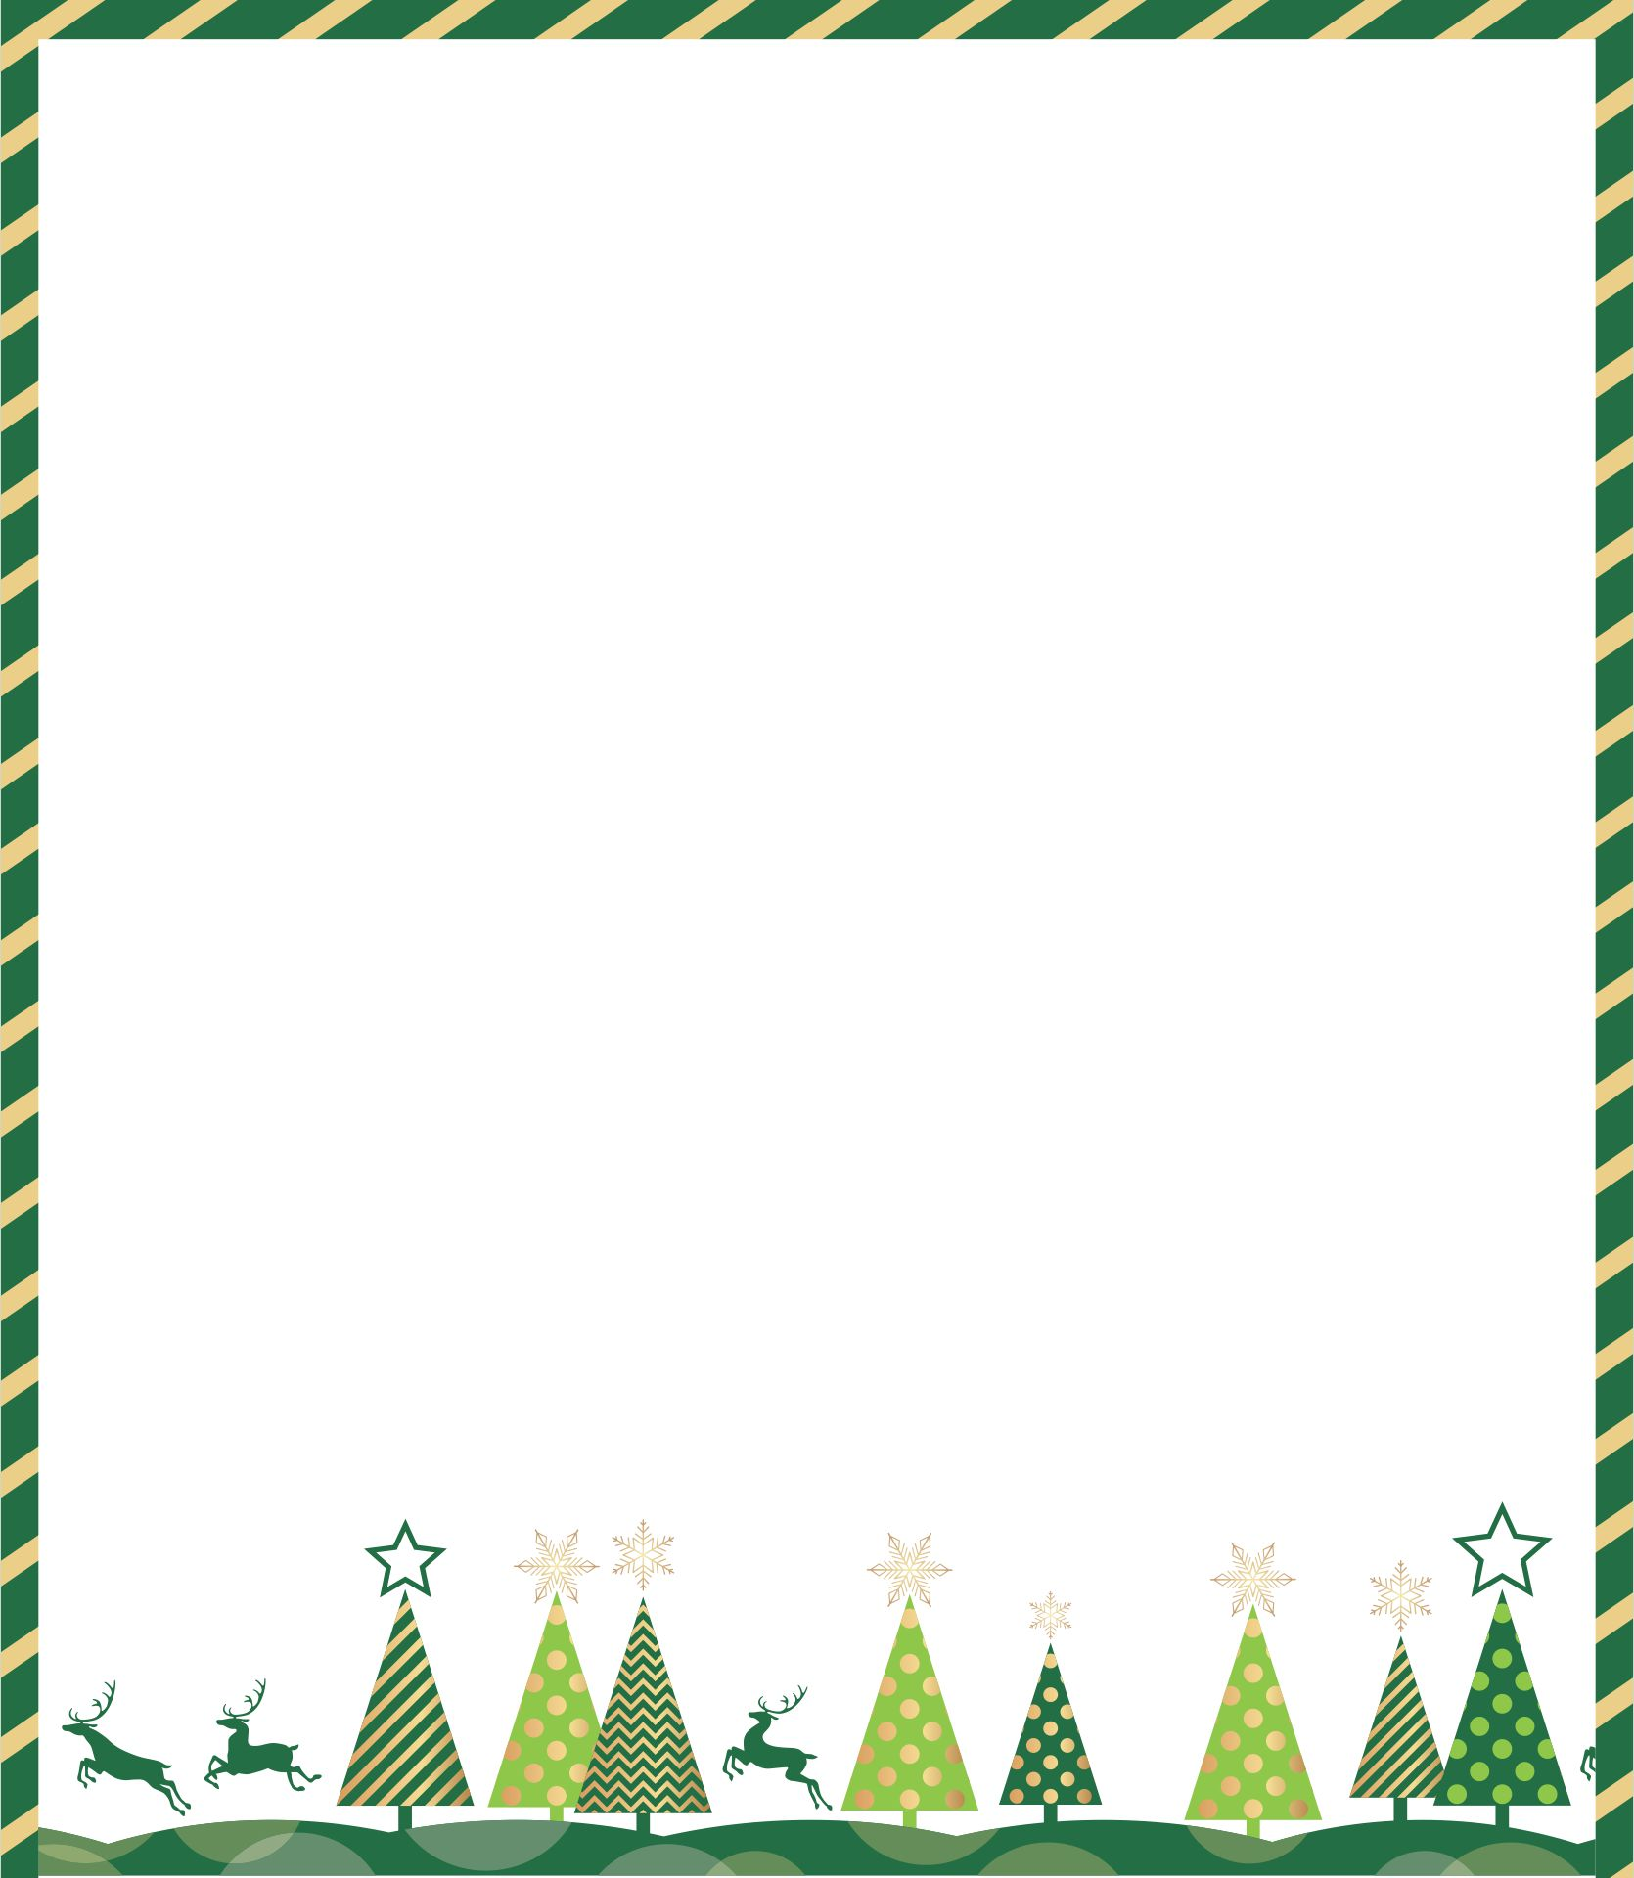

CHRISTMAS OPEN EVENING

**at** **THE TRIANGLE**

**64 Kingsmead, Farnborough**

**On Thursday 10th November**

**4.30-8.30pm**

**Come browse, and buy from our range of Fairtrade food, crafts, gifts, cards, books and much more.**

**Special discounts available on the night!**

**With refreshments provided!**