“Rushmoor Christmas Angels” June 2023 newsletter.

Hello everyone,
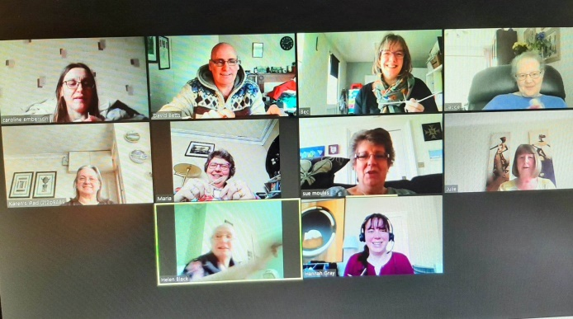
Firstly, a very big thankyou to everyone who contributed to our knitted Coronation celebrations.

Pictures of our post box topper were shared all over Social media and many comments were also made regarding the items we placed in Edgar Jerome’s window in Aldershot town too, so well done and thank you.

Speaking of Social Media the above picture showed up on my news feed recently. How strange to think that we once had Knitting parties via Zoom.
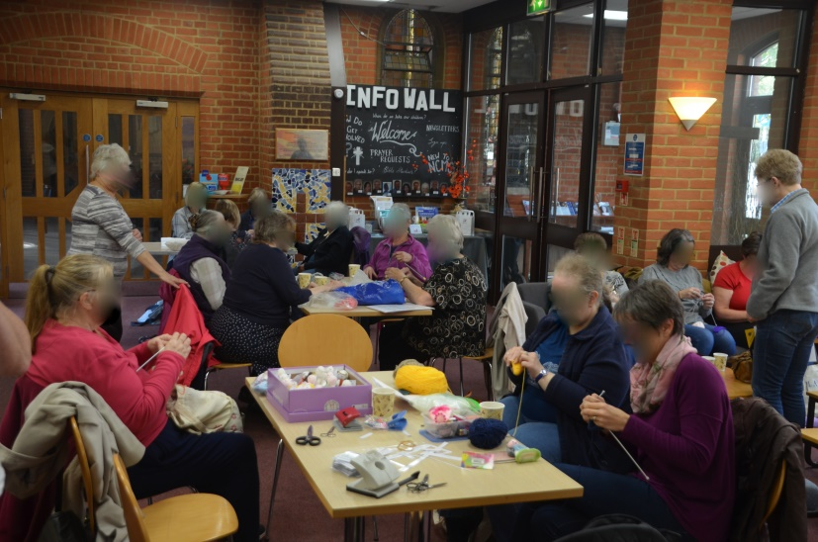
I also came across a picture from a time when the identity of our “Knitters” was a closely guarded secret

We were wondering what we might do with our knitted Coronation items so they would not just end up in a box in someone’s loft once the coronation celebrations were over. We were thinking that maybe we could gift these items to Rushmoor Borough council. This task was made much easier when (as most of you will probably now be aware) I was invited to be chaplain to the (new) Mayor of Rushmoor for his mayoral year 23/24. Our knitted crown, King Charles and Queen Camilla will now be offered to the council for safe keeping and (hopefully) be kept in the Mayor’s Parlour at the Council offices for all guests and dignitaries to see. I will invite the Mayor along to one of our knitting parties once his diary comes together.

Unless we have another pandemic (I hope not) or another national celebration (not for the foreseeable future) it is now full steam ahead ready for Christmas. It is hard to believe we are now almost half way through the year.

Thinking even further ahead, Christmas 2024 will be our 10th anniversary. A lot of things may happen between now and then, but we are thinking of maybe sowing a silver bead onto each angel that particular year in celebration of our achievement and to make finding one of our angels even more special.
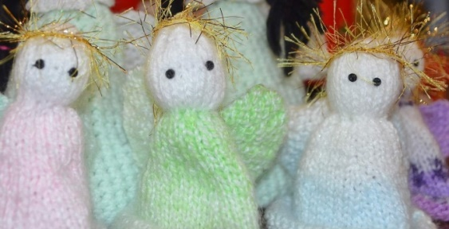
Did you know that the record for the longest knitted scarf stands at 4,565.46 metres? That’s nearly three miles. It was knitted by Helge Johansen of Oslo, Norway, and took him 30 years..

Our next Knitting Party will be on Saturday June 24th at North Camp Methodist Church.

As always a massive thank you to ALL of you for all that you do to make this project what it is. I look forward to seeing you all soon.

David Betts, 7 Redvers, Buller Road, Aldershot, GU11 2LT. dabetts4x4@btinternet.com 01252 328959 or 07941 997841

