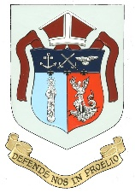

**St Michael & St George, Aldershot**

***The Cathedral Church of the Bishop of the Forces***

**Parish Office: 01252 315042**

**CHRISTMAS SERVICES 2024/2025**

**Tuesday, 24th December**

**CHRISTMAS EVE**

**2345hrs – Carols 2400hrs – Midnight Mass**

**Wednesday, 25th December**

**CHRISTMAS DAY**

**1100hrs – Mass of the Nativity of Our Lord**

**Thursday, 26th December**

**ST STEPHEN, PROTOMARTYR**

**1200hrs – Holy Mass with**

**Renewal of Altar Servers Commitment**

**Friday, 27th December**

**ST JOHN THE EVANGELIST**

**1200hrs – Holy Mass**

**Saturday, 28th December**

**THE HOLY INNOCENTS**

**1200hrs – Holy Mass**

**Sunday, 29th December**

**THE HOLY FAMILY OF JESUS, MARY & JOSEPH**

**1100hrs – Holy Mass**

**Wednesday, 1st January**

**MARY, THE HOLY MOTHER OF GOD**

**1200hrs – Holy Mass**