“Rushmoor Christmas Angels” March 2023 Newsletter.

Hello everyone and a very warm welcome to you if you are new to the “team” and this is your first “Rushmoor Christmas Angels” newsletter. It is great to have you on board
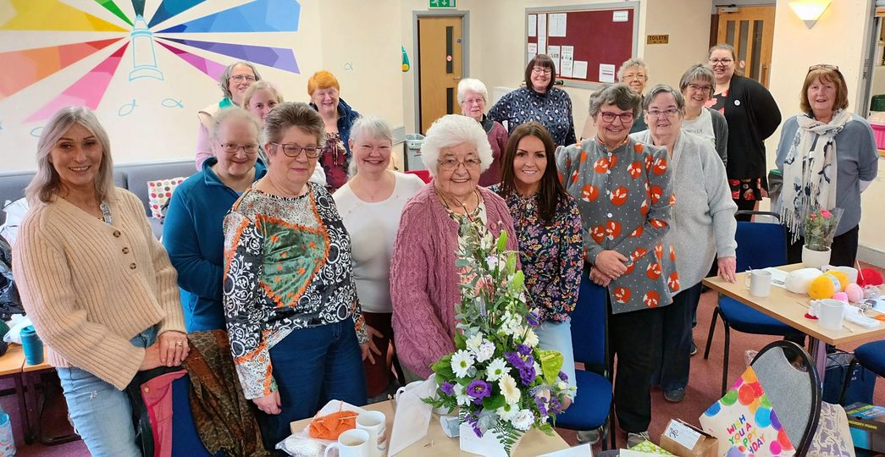
If you haven’t done so already do consider joining the “RCA Knitters” Facebook group. This is a really good place to keep up to date with all that is happening in the RCA knitters’ world

It was lovely to see you all at our last “Knitting party” a few weeks ago. It was especially lovely to celebrate with Ivy her 90th birthday.

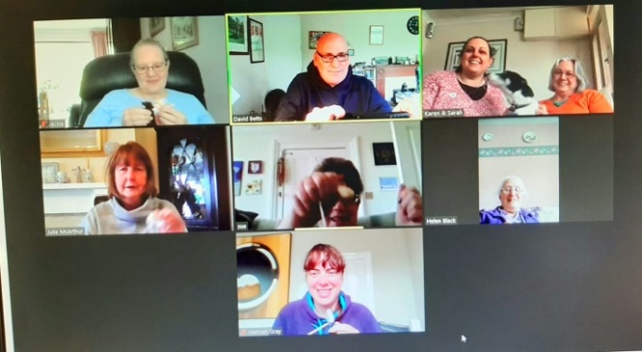
A few of us were reminiscing back to those times when we were unable to meet together and how during 2020 we would meet on Zoom for a few months (How strange that seems now). Then, when the restrictions were lifting we met in the church hall with all the windows and doors open and sitting 3m apart. How wonderful it is to be able to all meet together again in one space.

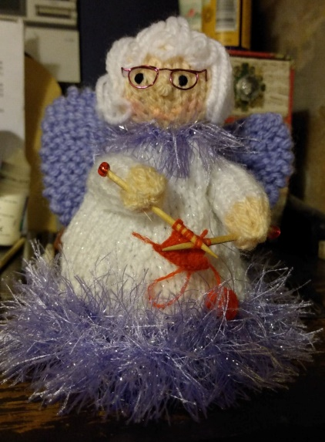
It can sometimes feel strange thinking about Christmas in March when we are still waiting to celebrate Easter. A quick google search however will reveal that we are not the only ones with Christmas on their minds this early in the year. In 2020 McAdenville in North Carolina, put its Christmas lights back up in March in order to lift people’s spirits during the Covid Pandemic. Residents of McAdeville were encouraged to drive around their community and have their “lockdown Lives” brightened up somewhat by the bright Christmas lights. So, knitting Christmas angels in March might not be quite as unusual a thing as it may at first seem.

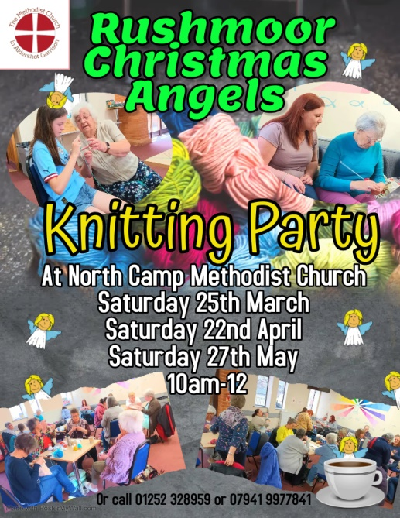
Those of you who were part of the RCA team in 2020 will remember that we branched out a little during that particular year and made over 1,000 NHS and Keyworker angels. There are plans in the pipeline to branch out again this coming May when we will do our little bit for the forthcoming Coronation.

Our next “knitting party” will be on Saturday 25th March at North Camp Methodist Church from 10am – 12 midday. Do check out the FB in our FB group highlighting the possibility of meeting midweek. There is a poll that you can take part in to help the planning of this….do check it out.

As always a massive thank you to ALL of you for all that you do to make this project what it is. I look forward to seeing you all soon. Please get in touch if you have any questions.

David Betts, 7 Redvers Buller Road, Aldershot, GU11 2LT. dabetts4x4@btinternet.com 01252 328959 or 07941 997841

