“Rushmoor Christmas Angels” August 2023

Hello everyone
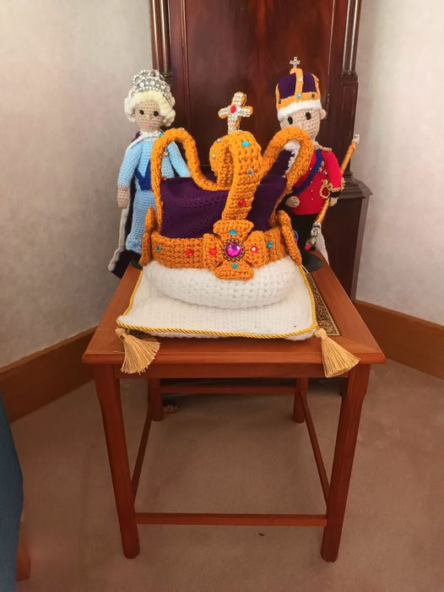
As always it was lovely to see you all at the last knitting party. In my role as chaplain to the Mayor of Rushmoor I was in the Mayor’s Parlour at Rushmoor Borough council offices a few weeks ago and there, taking pride of place below the Grandfather clock were our knitted King Charles, Queen Camilla, cushion and crown. I also spotted a few other Angels from previous years dotted around the room

We have some prolific knitters in our team and I am always amazed at the rate angels are produced…. BUT I have recently found out that the world record for the most stitches knitted in one minute is held by Miriam Tegels of The Netherlands who knitted an incredible 118 stitches in 60 seconds that works out at about 2 stiches every second. I wonder what we could do if we had Miriam on our team?
As I mentioned in a previous newsletter I guess some of you will be very soon packing your “knitting kit” in your suitcases as you venture off on your well-deserved holidays. If you are able to do take a picture of you and/or your knitting then please share it on the RCA Knitters Facebook page. There will be a small prize for the most unique/funny/ interesting knitting location submitted.

Not that I really want to mention the “C” word, (but as that particular “word” happens to be in our name I don’t suppose it really matters that much), but when we return from our holidays Christmas will be just over the horizon and we will start pulling together plans for this year’s launch and distribution. It is never too late to invite people to join us so do feel free to share the link to our Facebook group “RCA knitters” with anyone you think may be interested in coming on board.

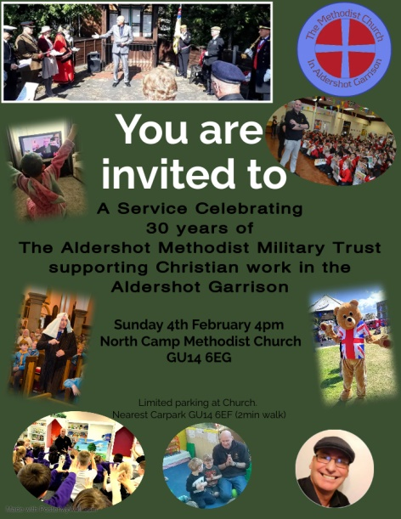
Next year will mark 30 years of my work in Aldershot Garrison. There will be a church service to mark this occasion. If you are able to get along I would love to see you. Also, if you are able to go on Facebook and indicate your intention to attend using the invitation on the RCA group page that will really help us with planning.

Things do start to get busy as we journey through Autumn so here are the dates of our new few “Knitting parties”.….Sept Sat 23rd, Oct Sat 21st and Nov Sat 25th. We will hold our Rushmoor Christmas Angels dedication carol service on Thursday Nov 30th at 7pm at North Camp Methodist Church. I will make sure that there are regular reminders of these dates on the Facebook page and via the monthly newsletters

As always a massive thank you to ALL of you for all that you do to make this project what it is. I look forward to seeing you all soon.

David Betts, 7 Redvers, Buller Road, Aldershot, GU11 2LT. dabetts4x4@btinternet.com 01252 328959 or 07941 997841

