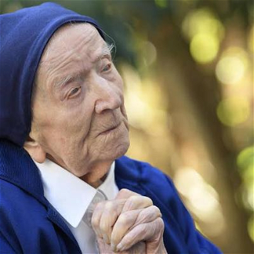

Sister Andre Randon, a French nun, has died aged 118. She died in her sleep at her nursing home in Toulon, France. Born in 1904 in southern France, she lived through two world wars.
She had been Europe's eldest for some time, but she entered the Guinness Book of Records in April 2022 as the world's oldest person following the death of a Japanese woman who lived until she was 119 years old. It was not her first time in the record books. In 2021 she became the oldest person to recover from Covid-19.

Sister Andre was born into a Protestant family but converted to Catholicism at 19 years old. She joined the Daughters of Charity at the age of 40 in 1944. She was assigned to a hospital in Vichy, where she spent most of her working life.

A spokesman from her nursing home, David Tavella, said, "there is great sadness but... it was her desire to join her beloved brother and for her, it's a liberation." Sister Andre was said to have had a close relationship with her brothers. She once told reporters that one of her fondest memories was their safe return from fighting at the end of World War One. "It was rare," she recalled, "for in families there were usually two dead rather than two alive".

Upon her 115th birthday in 2019, Sister Andre received a card and a blessed rosary from Pope Francis, which she used every day. When she turned 116 in 2020, she shared her "recipe for a happy life" - prayer and a cup of hot cocoa every day. In one of her last interviews, she told reporters: "People should help each other and love each other instead of hating. If we shared all that, things would be a lot better."

